**Chapter 4**

**Theory and Methodology**

**4.1 Ground Penetrating Radar**

Ground penetrating radars have been used to map subglacial and englacial interfaces of the ice sheet for a long time. The basic principle of an ice penetrating radar is that electromagnetic waves are sent from the transmitter through array of transmit antennas into the ice sheets where it’s backscattered whenever there is discontinuity of dielectric constant thus giving sharp backscattered echoes from the surface, internal layers and the bottom as there is transition from air to ice and ice to rock/water. The dielectric of water is 80, rock is 4-12 and 3.2 for the ice, which is why there are two sharp peaks in the received echoes. The receive antenna different from transmit antenna or the same antenna is used to capture the backscattered echoes. The data used in this study is collected by a multichannel coherent radar depth sounder (MCoRDS) which uses array of antennas for better SNR of the received echo. It uses along track focusing by SAR processing and pulse compression in fast time to generate echograms usually for every 50 km. The two way travel time for the surface and bed are then used to determine the depth of the ice sheets. Ice Surface and bottom are tracked using automatic tracker developed at CReSIS with some manual corrections.

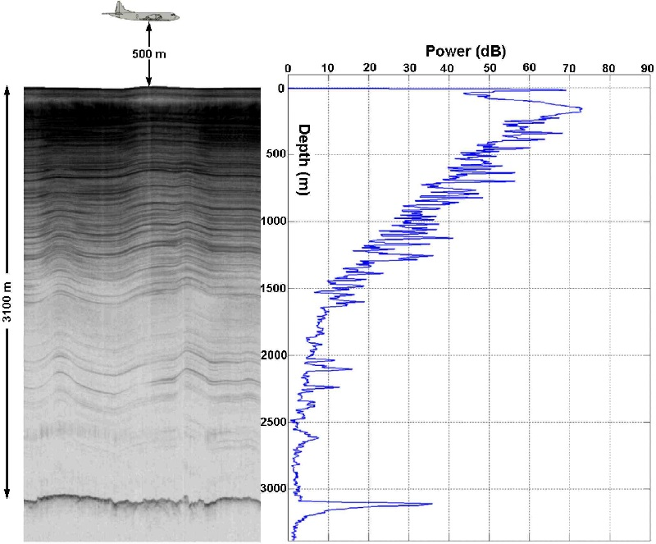

Fig. Echogram with ice layers (left) A-scope (right)

Figure shows an echogram (left) that shows ice surface, internal layers and the ice bed (at 3100m) clearly. The A-scope shows two distinct peak powers at ice surface and the ice bed.

This bed can be rock of different dielectric constants 4-12 or could be water of dielectric constant 80. The backscattered echo strength depends on the dielectric constant hence may indicate water (wet bed) for higher reflectivity and rock for lower reflectivity (frozen bed).

**4.2 Methodology**

When signal propagates through the ice, the bed echo strength is given by the equation

[𝑃]𝑑𝐵 = [𝑆]𝑑𝐵 −[𝐺]𝑑𝐵 + [𝑅]𝑑𝐵 − [𝐿]𝑑𝐵

where bed echo strength (P) is function of radar system parameters (S), geometric spreading loss(G), bed reflectivity(R) and englacial attenuation (L). So to calculate the reflectivity ‘R’ of the bed we need tp compensate all the other parameters from the bed echo strength ‘P’. This bed reflectivity can be used to analyze whether the bed is frozen or thawed [Evans 2004, Oswald 2008].

***4.2.1 Geometrical Spreading Loss***

When the signal is radiated from the antenna then the power of the signal is continuously reduced when it travels away from the antenna. The geometric loss at ice depth $‘d’$ when radiated from an antenna with gain $‘g’$ radiating signal of wavelength ‘ $λ'$ at the height of $‘h’$ is given by

$$G=2×{[2\left(h+\frac{d}{\sqrt{ε}}\right)]}_{dB}$$

Using the two-way propagation time for ice surface and ice bed, the depth of ice sheet is calculated from which the corresponding geometrical spreading loss is derived.

Geometrically corrected bed-echo power 𝑃𝑐 is then given by

[𝑃]𝑑𝐵 + [𝐺]𝐵 =[𝑃𝑐]𝑑𝐵= [𝑆]𝑑𝐵+[𝑅]𝑑𝐵−[𝐿]𝑑𝐵

Rearranging the above equation gives

[𝑅]𝑑𝐵= [𝑃𝑐]𝑑𝐵+ [𝐿]𝑑𝐵−[𝑆]𝑑𝐵

Assuming the system is stable for a season and the losses due to birefringence negligible (<2 dB) (Fujita 2006) then correcting the ice bed power for these losses will give us ice bed reflectivity which can be analyzed to infer ice bed condition.

***4.2.2 Englacial Attenuation***

One of the ambiguities introduced in the ice sheet modeling with radar data is due to the variable ice attenuation rates. The englacial attenuation rate varies due to scattering, variable dielectric constant of snow/ice, ice impurities, and complicated internal structures within the ice sheet hence it is spatially variable. The englacial attenuation rate [L] is related to depth as:

$L=2N_{a}h$

Where $N_{a}$ is englacial attenuation rate ($dB/km$) and $h$ is the depth of ice sheet. $N_{a}$ usually ranges from 3 to 30 dB for grounded ice (Matsuoka 2012). If we assume a constant ice attenuation rate then it produces a widely spread ice bed reflectivity which can’t explain the transition between frozen and wet bed. A transition from frozen to wet bed would correspond to an increase in about 10dB (Macgregor, 2013).

The reflectivity due to dielectric constant difference can be shown as:









Here we can see that the reflectivity would be higher for ice water interface compared to ice rock interface due to difference in dielectric constant.

Hence if englacial attenuation isn’t properly compensated then a realistic bed reflectivity can’t be obtained so it’s imperative that the englacial attenuation is properly compensated. Several methods have been used to estimate the englacial attenuation and calculate the ice bed reflectivity which is discussed in Chapter 6.

Apart from these losses roughness is also another way the power loss occurs hence compensating for surface and bed roughness can yield a better bound in calculated ice bed reflectivity. Chapter 5 discusses the estimation of roughness and its compensation.

***4.2.3 Abruptive Index***

Oswald and Gogineni, 2008 have used high abruptness as another indicator of basal melt since the transition from ice to flat lying water bed gives a specular echo. Abruptive index is defined as $$I_{abr}=\frac{P_{peak}}{P_{ag}(x)}=\frac{{({\left\{P\right\}}_{X})}_{peak}}{{\{\sum{D_{int}P\}}}_{X}}$$

Where $P_{peak}$ is the bed power and $P_{ag}\left(x\right)$ is the aggregate power over the echo envelope ‘ $D_{int}'$ which is the depth bins and is given a threshold of 5% of the peak power. It’s value lies usually between 0.05 and 0.5. A threshold value of abruptive index is put upon the interface that is flat at the scale of ice depth to indicate possible basal melt.

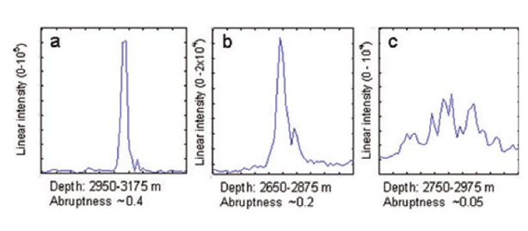

Figure 3. High Abrupt , Abrupt and less abrupt signals from flat and rough surfaces [1]

***4.2.4 Coherence Index***

To measure the interface smoothness, the coherence index of the bed needs to be calculated which is given by equation

$$I_{CO}=\frac{\int_{D_{int}}{<|\int_{X_{int}}{|{ψ\left(D,x\right)dx|}^{2}>dD}}}{\int_{D_{int}}{\int_{X_{int}}{{|ψ(D,x|}^{2}}}dxdD}$$

where D is the ice depth, x is the along track distance interval for integration, and $X_{int}$ is the along track interval for both coherent and incoherent integrations, the length of the radar footprint at ice bed, usually 200 meters, and $D_{int}$ is the aggregation interval of the basal echo envelope.

If there is water at the bed then due to pressure gradient it forms a flat surface hence the areas with flatter surfaces and high reflectivity are representative of basal melt (Oswald, 2003).